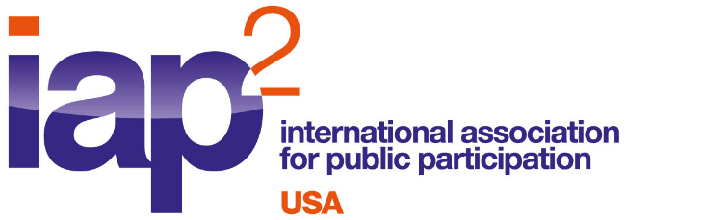
News Release: For more information:
September 26, 2023 Gail Madziar, IAP2 USA
gail@iap2usa.org, 517-676-4341
www.iap2usa.org
John Angelico, SFMTA
John.Angelico@SFMTA.com
415-646-4783

San Francisco Municipal Transportation Agency Receives National Honors
for Reimagining Potrero Bus Yard
International Association for Public Participation (IAP2) USA awarded San Francisco Municipal Transportation Agency (SFMTA) the IAP2 USA Core Values Award in the General Projects Category for their project Reimagining Potrero Bus Yard.

The San Francisco Municipal Transportation Agency (SFMTA) manages all San Francisco’s ground transportation for the city. The SFMTA oversees the Municipal Railway (Muni) public transit system, as well as bicycling, paratransit, parking, traffic, walking and taxis. Pre-pandemic, its transit system, Muni, transported more than 700,000 people during a typical weekday. The SFMTA is committed to involving the people of San Francisco in the decisions that shape the city’s transportation system so that those who are affected by government decisions are informed and have an opportunity to participate in the decision-making process.

“This project not only expands and modernizes a 100-year- old bus yard, it also provides critical housing, community spaces and services that we co-designed with the surrounding neighborhood,” said SFMTA Director of Transportation Jeff Tumlin. “The input we got from a broad diversity of community members definitely improved the project design.”

“It was remarkable that what could have been approached by SFMTA as a simple modernization of a bus yard project instead acknowledged the community’s gentrification issues and created a multiple benefit project that addressed the community’s affordable housing challenges in a meaningful way,” said Heather Imboden, IAP2 USA president.

The IAP2 Core Values Awards are presented each year to projects that best exemplify IAP2’s guiding principles. SFMTA received their award at the annual Gala held at the IAP2 North American Conference in Seattle, WA on September 14, 2023.
Founded in 1992, the International Association for Public Participation advocates for and supports the practice of Public Participation, which is based on the premise that people affected by a decision have a right and expectation to have their opinion, position and interests heard and considered. IAP2 USA now has more than 2,500 members.
##

