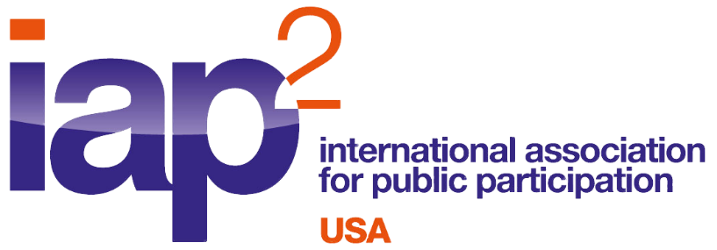

NOMINATIONS DUE BY JUNE 30, 2021
Greater Good Awards are presented each year by the International Association for Public Participation (IAP2) USA in recognition of excellence in the field of public participation in the United States. The IAP2 USA President presents the award after selecting one or more nominees who have demonstrated outstanding leadership, service, and application of the IAP2 core values (attached) in the field of public participation. Candidate(s) may be nominated by any IAP2 USA Member, Chapter or Committee.
There are two categories of awards:
- Greater Good Award: In recognition of people who have exerted leadership and made an impact on the profession over a period of years.
- Greater Good - Emerging Leader Award: In recognition of emerging leadership (for people who are under 35 and/or have fewer than five years in the practice) and are making a new impact on the profession.

Nominations must include the following:
- Nomination form (below)
- A written, detailed biography (no more than 1000 words) on this individual. Biography should include one or more of the following:
  - How this individual has contributed in service to the field of public participation.
  - How this individual has provided mentoring to others in the field of public participation.
  - For the Greater Good Award: How this individual has advanced the practice of public participation by:
    - Advocacy
    - Development of tools/techniques
    - Application of the IAP2 core values.
  - For the Greater Good - Emerging Leader Award: How has this individual contributed fresh energy, generated creative ideas, or provided exceptional support of IAP2 USA programs, including chapters.
- Two letters of recommendation presented in support of this individual’s nomination.

Presentation of the awards will be made during the online IAP2 North American Conference this September. IAP2 USA encourages winners to attend and participate in the Conference. To encourage and support future growth of the practice, winner(s) of the Greater Good - Emerging Leader Award will receive one complimentary conference registration fee to encourage their participation in the conference.

Please fill out the form below and submit to IAP2 USA. The deadline for nomination is June 30, 2021 Please submit nominations to Gail Madziar gail@iap2usa.org in Word format.

Please select one: Date Submitted:

GREATER GOOD AWARD GREATER GOOD - EMERGING LEADER AWARD

Nominee Name:

Nominating individual, committee, organization:

Name:
Title/Organization:
Address:
Phone:
Email:

Biography (no more than 1000 words). Biography should include one or more of the following:
  - How this individual has contributed in service to the field of public participation.
  - How this individual has provided mentoring to others in the field of public participation.

For the Greater Good Award: How this individual has advanced the practice of public participation by:
    - Advocacy
    - Development of tools/techniques
    - Application of the IAP2 core values.

For the Greater Good - Emerging Leader Award: How has this individual contributed fresh energy, generated creative ideas, or provided exceptional support of IAP2 USA programs, including chapters.

Two letters of recommendation presented in support of this individual’s nomination.

IAP2 developed the Core Values for the Practice of Public Participation for use in developing and implementing public participation processes to help inform better decisions that reflect the interests and concerns of potentially affected people and entities. The Core Values were developed with broad international input to identify those aspects of public participation that cross national, cultural, and religious boundaries.

- Public participation is based on the belief that those who are affected by a decision have a right to be involved in the decision-making process.

- Public participation includes the promise that the public’s contribution will influence the decision.

- Public participation promotes sustainable decisions by recognizing and communicating the needs and interests of all participants, including decision makers.

- Public participation seeks out and facilitates the involvement of those potentially affected by or interested in a decision.
- Public participation seeks input from participants in designing how they participate.

- Public participation provides participants with the information they need to participate in a meaningful way.

- Public participation communicates to participants how their input affected the decision.

The Core Values define expectations and aspirations of the public participation process. Processes based on the Core Values have been shown to be the most successful and respected.

IAP2 core values

