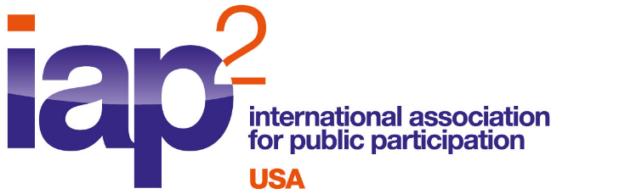
2013 Year in Review
The number of active and pending members in IAP2 USA dropped slightly in 2013 from 511 to 492, as of December 31, 2013.
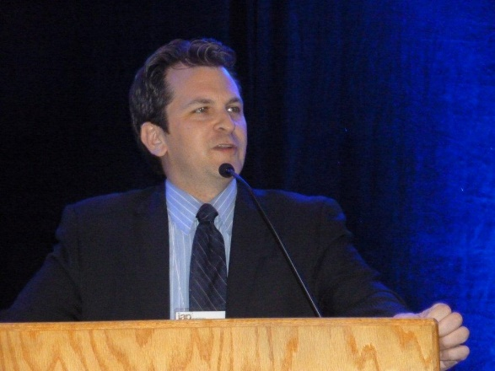
Board Members in 2013
- President – Larry Schooler
- President-Elect – Doug Zenn
- Treasurer – Theresa Gunn
- Secretary – Debra Duerr
- Federation Representatives –
  - David Hovde
  - Theresa Gunn (through 06/2013)
  - Lance Robertson (from 06/2013)
- Tim Bonnemann
- Leah Jaramillo
IAP2 USA President Larry Schooler, welcoming participants to the 2013 IAP2 North American Conference in Salt Lake City, UT
- Wendy Lowe
- Kimberlee Acker (through 06/2013)
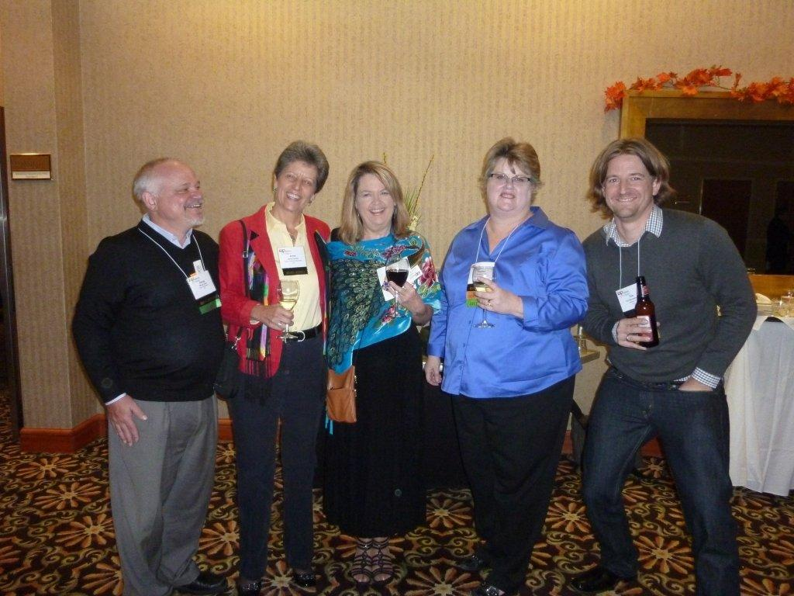
Some of the 2013 IAP2 USA Board (l-r): Doug Zenn, Anne Carroll,
Wendy Lowe, Theresa Gunn, and Tim Bonnemann
2013 IAP2 North American Conference

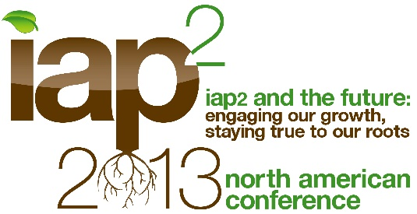
IAP2 USA hosted the 2013 North American Conference (it alternates with Canada as host Affiliate). The three-day event in Salt Lake City included a keynote address from Salt Lake City Mayor Ralph Becker, whose own consulting business involves public participation. Over 200 participants attended, and with over 60 high-quality conference sessions, one of the main criticisms of the event was that the Conference could have run three days, rather than two. In all, the presentations earned excellent evaluations from those taking part.

One of the Conference highlights was the presentation of the Core Values Awards. Project-of-the-Year honors were shared between two very different and very effective projects: the City of West Hollywood, for its 2013 Community Study; and Healthy Democracy Oregon, for its Oregon Citizens’ Initiative Review.
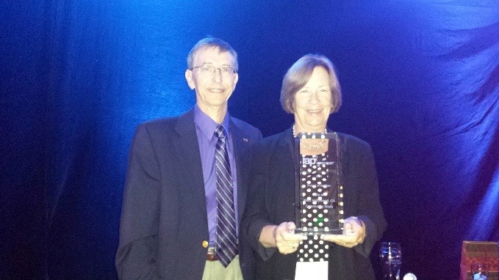
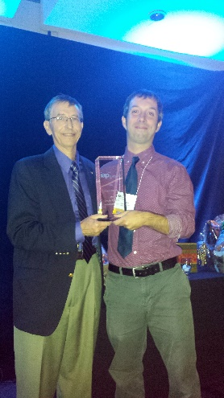

Lewis Michaelson presented the Core Values Awards: to Daphne Dennis of the City of West Hollywood and Tyrone Reitman of Healthy Democracy Oregon

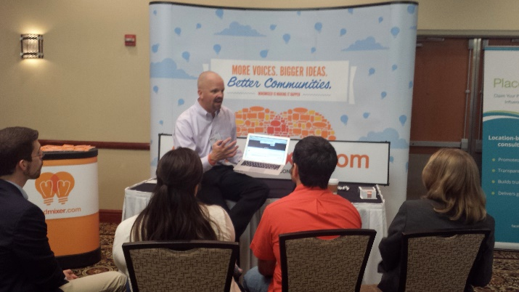
The Conference featured a new offering: a technology fair, which showed off a variety of new tools – mostly online engagement tools – for increasing the scope and efficiency of public engagement processes. It proved to be a popular feature for both participants and vendors alike, and will be included at the upcoming 2014 North American Conference in Winnipeg, Canada.
The Conference made use of modern technology in its own right, videotaping about a dozen conference presentations. These are being rolled out to the public via the IAP2 USA website and blog.
The Conference was also a financial success, contributing over $28,000 to the Affiliate’s net income.

Learning Webinars
IAP2 USA continued offering monthly Learning Webinars through 2013. Working in collaboration with IAP2 Canada, these webinars – held on the second Tuesday of each month – covered a variety of topics of interest to IAP2 members on both sides of the border, including the Core Values Awards, Participatory Budgeting and the importance of diversity in planning public participation. These webinars are recorded and are available, along with collateral material from the presenters, for members only (and non-members who paid to take part in the sessions).
Financials
IAP2 USA ended 2013 in very positive financial condition, with end-of-year assets of $52,668.11, of which $22,654.26 remained restricted as reserve. Total revenues excluding the 2013 North American Conference were nearly $58,748.23, with over 91% coming from memberships.
Administrative support continued to account for the majority of Affiliate expenses in 2013. These were paid to a contract administrative firm for part of 2013, but the board shifted to the use of individual contractors mid-year to improve service and cut costs. With those reductions, expenses came in lower than in 2012 in spite of significant additional administrative support provided to the 2013 North American Conference.
The 2013 North American Conference hosted by IAP2 USA netted the Affiliate $28,727.47, resulting in a net income for 2013 of $33,457.01.
Communications Committee
Our Communications Committee kept members informed about Affiliate happenings with a monthly email newsletter, regular postings on the IAP2 USA blog and via social media. Follower and subscription numbers have increased significantly across all channels in 2013.

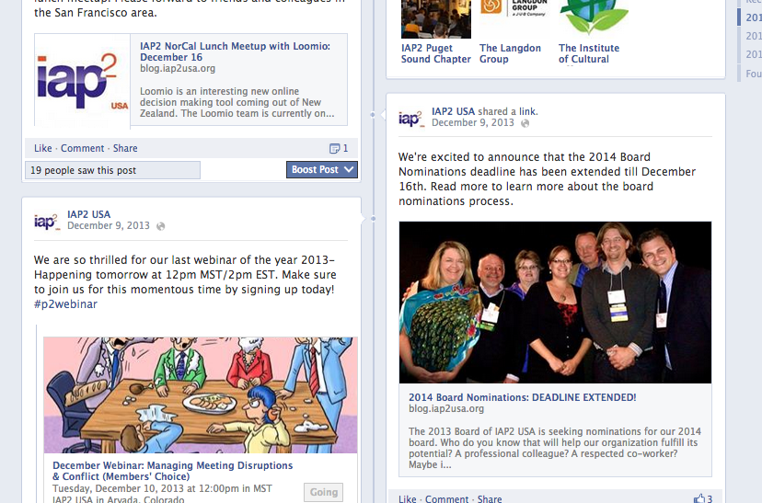
A robust planning effort at the beginning of the year allowed us to focus our resources on a few key areas, including promotion of the IAP2 2013 North America conference. A series of posts in the spring/summer featured conference presenters, and a new monthly segment "Member Spotlight" celebrates the diversity, skills and contributions of our members across the country.
IAP2 USA continued to reach out to members and non-members via Facebook and other social media

Another strategic accomplishment involved the production of high-quality video at the conference (see above). Expanding the use of video is high on our list of priorities for 2014. A series of informal video clips of IAP2 USA members discussing various attributes of the organization and the benefits of getting involved with IAP2 will become available shortly.

Our team has grown to four members, and we are actively seeking additional volunteer support across a broad range of roles and responsibilities, from occasional contributor to on-call videographer to chief editor.

IAP2 USA: Vision for 2014
The outgoing 2013 board provided direction from its strategic planning efforts to lay the foundation for the 2014 board. This included continuing with strategic partnerships development, increasing communications tools and services for membership and focusing on membership growth. The 2013 board also forwarded its plans for additional training opportunities for implementation in 2014.
Finally, the 2013 board laid the foundation for hiring a permanent administrative director, which was completed at the end of 2013.

